This UML graph describes the data model of “credit transfer” part. (not include “sample study plan”).

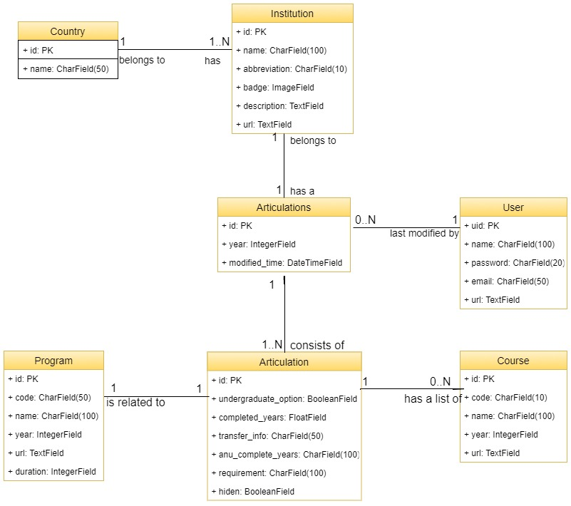

**Data model description:**

**Country**

|  |  |
| --- | --- |
| id | AutoNumber identity, primary key |
| name | Country name |

Each country has a list of institutions.

**Institution**

|  |  |
| --- | --- |
| id | AutoNumber identity, primary key |
| name | Official name |
| abbreviation | Abbreviation for the institution |
| badge | Image of institution badge |
| description | Description of the institution |
| url | Link to the official website |

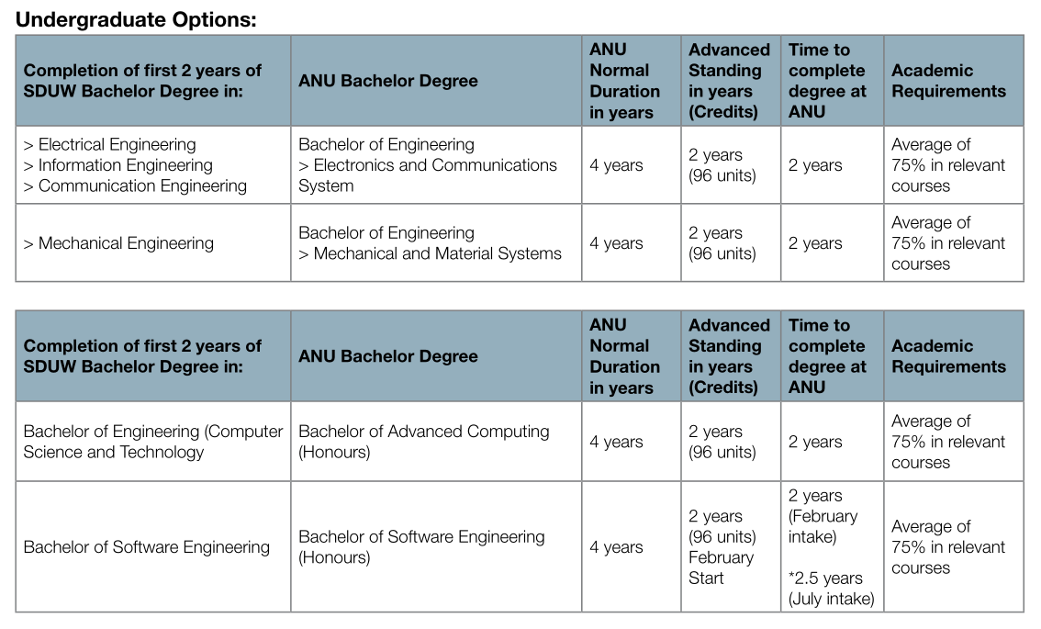Each institution has an “*Articulations*” which consists of a group of “*Articulation*”.

e.g. The picture below is an “*Articulations*” which has four “*Articulation*” (each row is an *Articulation*).

**Articulations**

|  |  |
| --- | --- |
| id | AutoNumber identity, primary key |
| year | Year of the articulation rule |
| modified_time | Last modified time |

**Articulation**

|  |  |
| --- | --- |
| id | AutoNumber identity, primary key |
| undergraduate_option | True for undergraduate and false for postgraduate |
| completed_years | How many years the student has completed in current degree |
| transfer_info | Advanced standing info. (e.g. 2 years (96 units), Entry only) |
| anu_complete_years | Time to complete degree at ANU. (e.g. 1.5 years) |
| requirement | Academic requirements (e.g. Average of 75% in relevant courses) |
| hiden | Default false. True if this Articulation is hidden |

• undergraduate_option=True, completed_years=2.5 means this *Articulation* is for undergraduate students who have completed 2.5 years Bachelor Degree.

• undergraduate_option=False, completed_years=0 means this *Articulation* is for postgraduate students who have completed Bachelor Degree.

• undergraduate_option=False, completed_years=1 means this *Articulation* is for postgraduate students who have completed 1st year Master Degree.

Each “*Articulation*” is associated with an *ANU program*. For example, in this *Articulation*, the related program is “Bachelor of Software Engineering (Honours)”.

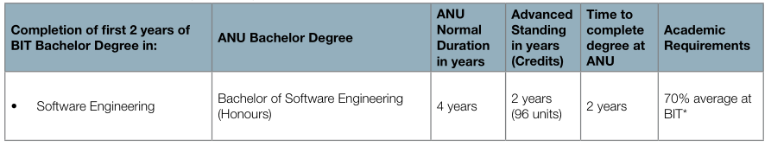

**Program**

|  |  |
| --- | --- |
| id | AutoNumber identity, primary key |
| code | Program code |
| name | ANU program name |
| year | Year of the program |
| duration | Program duration in years |
| url | Link to the ANU program page |

Each *Articulation* has a list of courses for advanced standing. For example, the table below shows the courses for advanced standing of an *Articulation*.

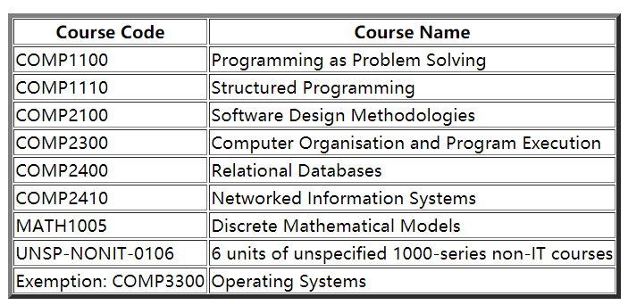

**Course**

|  |  |
| --- | --- |
| id | AutoNumber identity, primary key |
| code | ANU course code |
| name | Course name |
| year | Year of the course |
| url | Link to the course page |